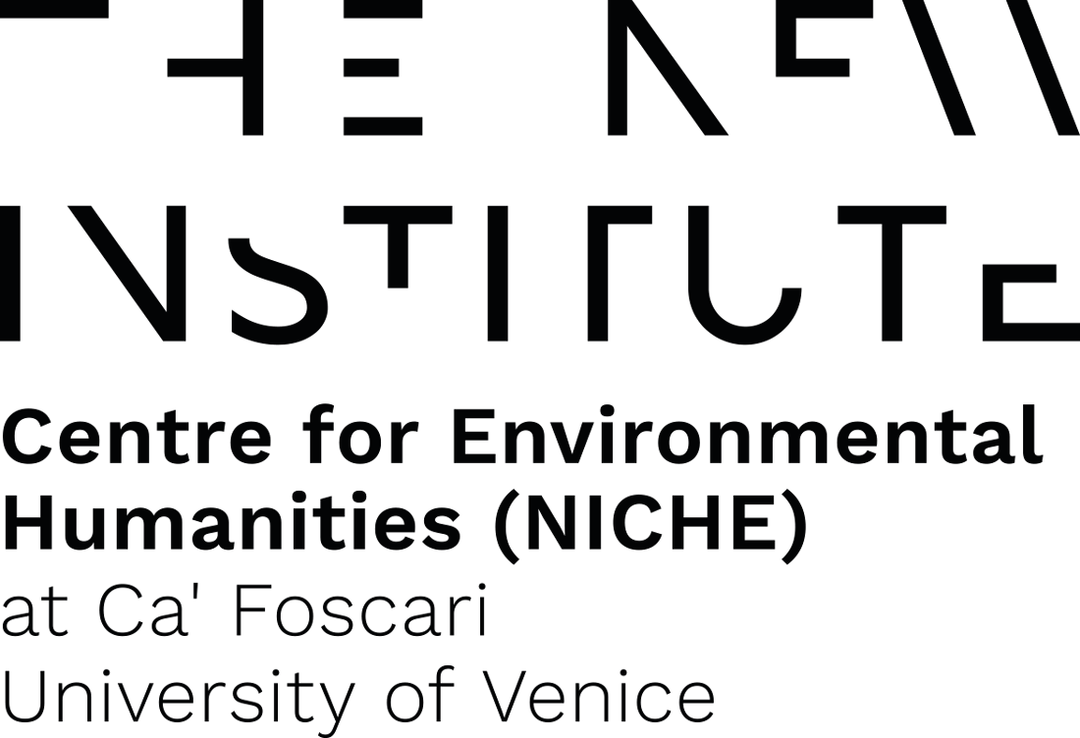

CALL FOR ABSTRACTS
Zoopolitics of Life and Death

Critical Animal Studies Graduate conference,
October 17th and 18th 2023
THE NEW INSTITUTE Centre for Environmental Humanities (NICHE) at Ca’ Foscari University of Venice & Institute of Philosophy and Art History (IPK), Kulturwissenschaften Faculty at Leuphana University, Lüneburg
The concepts of zoopolitics and biopolitics (following Foucault’s theorization) have traditionally been addressed separately, based respectively on a – contested (Derrida) but philosophically pregnant (Agamben) – distinction of zoé and bios. These, as two different Greek terms for “life” in the work of Aristotle (Politics), have been used, in the first case, to merely refer to the lives of nonhuman animals, and the second to a distinctively human form of life. However, we think that these terms need to be articulated together to address the multispecies composition of contemporary natureculture assemblages and their lively capital (Haraway; Helmreich).
The always situated lines running through humanity and animality, the animate and the inanimate (Chen), the organic and the machinic (Haraway), what is deemed worth living, saving, preserving and what is expendable and killable, are, at once, dividing and implicating: it is around such ideological and material boundaries that the logic and apparatuses of exploitation, extractivism, marginalization, domination are structured and sustained. Today, biopolitics (Foucault), techno-biopolitics (Haraway), zoopolitics (Agamben, Derrida), molecular biopolitics (N. Rose) necropolitics (Mbembe) show how animal life and death are increasingly defined and managed in order to be capitalized, starting from the very appearance of life itself.
Thus, in a Critical Animal Studies perspective, addressing the biopolitics of human-nonhuman relations and the divides between them we cannot ignore the nonhuman “counterpart”, which means addressing zoopolitics, and the contiguity of the two (Shukin; Wadiwel; Piazzesi). After all, life always acknowledges, creates and sustains relationality, as Feminist Animal Studies underline, from Ecofeminism (Adams, Gaard, Gruen, Donovan) to new materialist and compostist approaches (Alaimo, Barad, Haraway). Following the principles of Critical Animal Studies, we thus adopt a holistic approach to confront oppressions (Fitzgerald and Pellow), shared exploitation and vulnerability, but also to put liveability and flourishing according to a total liberation framework to the forefront (Best, White, Nocella II).
In this spirit, the conference welcomes both theoretical and empirically-oriented papers on topics critically addressing the politics of life and death of nonhuman animals from the fields of the Humanities and the Social Sciences, including but not limited to the following themes and areas:

- The zoopolitical turn
- The Ag-Tech industry complex
- Nonhuman animals within capitalist societies
- Multispecies reproductive justice
- Productive and reproductive labour
- Social justice movements and Critical Animal Studies
- Ableism, racism, and speciesism: selection, taxonomies, categorization, eugenics
- Power/knowledge of and over bodies
- Queering normativity, resisting identification
- Disposable lives, killable bodies, hunting, pests, animal genocide
- Forms of “rendering”
- The display of animals: the zoopticon, trophies, performance, the arts, taxidermy, zoos, circuses
- Prisons, cages and other forms of animal life erasure
- Space, borders, walls: containment and mobility
- Health, risk, vulnerability
- Toxicity and endangered lives
- Ecocide, extractivism, extinction
- Veganism as life politics
- Buddhism and veganism, Critical animal studies in Asia
- Politics of mourning, memory and witnessing
- Practices of care
- Liberation, resistance, desire, empowerment
- Biodiversity, restoration, maintenance, flourishing
- Indigenous and Non-Western worldviews and multispecies practices
- Histories, genealogies and futures of multispecies politics and communities

The conference will be held in English, presentations will have a 15-20 minute length, depending on the schedule.
To participate as presenters, please use this google form to provide:
- An abstract text betw. 350 and 450 words + 3 references + 5 keywords
- A brief biography of the author (150 words maximum) including name, affiliation and contact details

- Start of Abstract Submission: 15 March 2023
- Deadline for abstract submission: 30 April 2023
- Notification of acceptance: 31 May 2023
Registration for presenters and attending students needing certification is mandatory (it will be possible to register after abstract selection ends).
Presenting participants and attending students needing certification are kindly asked to attend in presence.
Papers will be selected for publication after the conference closure.
Please note that the conference has no registration fee, and will take place in presence and online in Venice and in Lüneburg at the same time.
For any inquiry and additional information, please write to Chiara Stefanoni (Leuphana University) and Federica Timeto (Ca’ Foscari University) at: zoopolitics.conference@gmail.com

