AoL – Assurance of Learning

# The background to Assurance of Learning

Assurance of Learning (AoL) is a quality management tool which evaluates study programs as a whole. It allows us to monitor whether students acquire the set of competences and skills which the program is designed to offer. AoL complements Leuphana’s well-established quality management tools related to program accreditation such as teaching evaluations, which focus on individual courses and teachers, and the student-teacher-exchange in Quality Circles. In comparison, AoL allows to reflect on and implement measures for strategic improvement of the programs and study experience.

# The Process of Assurance of Learning

The AoL follows a structured control loop. The following paragraphs offer a more detailed view on the different steps of the AoL-process.

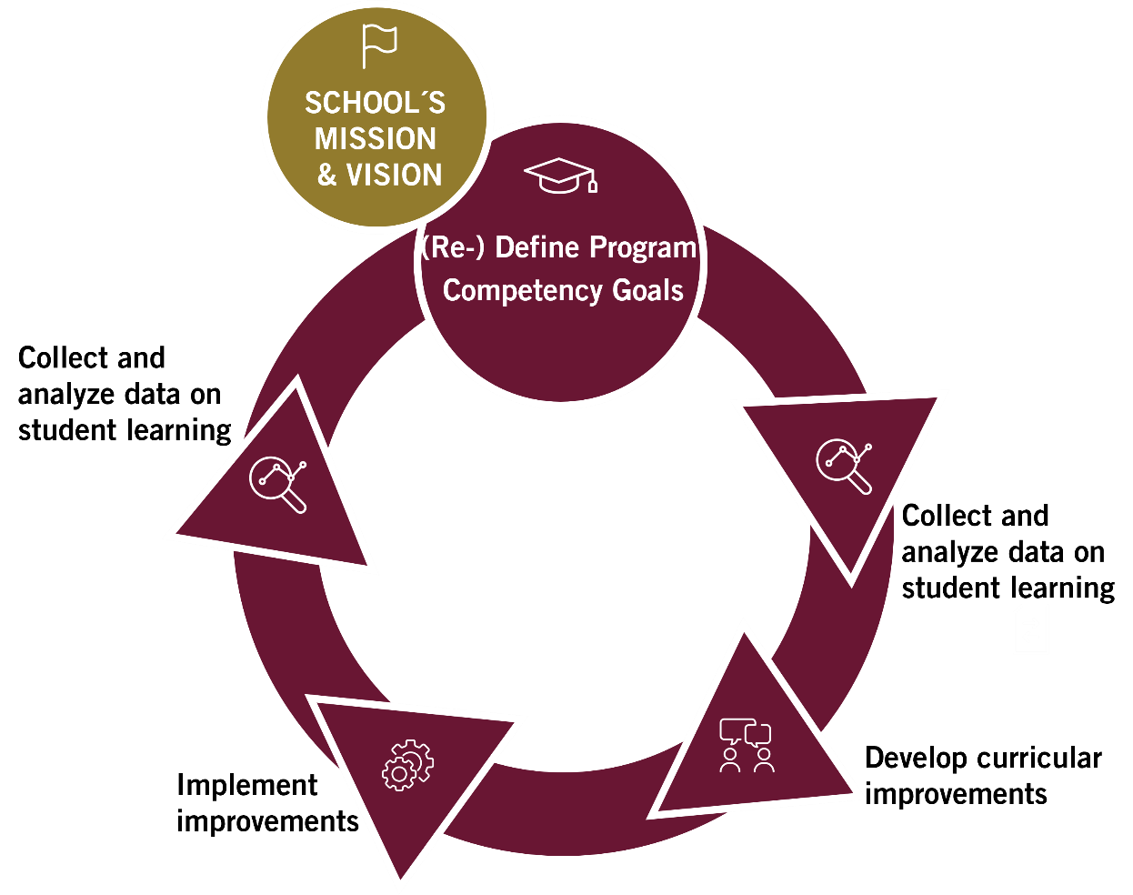Figure 1: **The Assurance of Learning control loop**

The Assurance of Learning is a systematic process based on measurements of student learning, the identification and implementation of improvements and the monitoring of outcomes through repeated measurements. For this, measurable Learning Objectives are defined for each Competency Goal.

## Definition of Program Competency Goals

The Assurance of Learning system starts with the definition of Program Competency Goals. These program-specific Competency Goals express the educational expectation regarding a program’s core characteristics and are aligned with the school’s mission and the FSA Learning Objectives. While the specific learning objectives vary by program, they are all grounded in four overarching dimensions:

**Disciplinary knowledge and expertise**: Understanding and applying core concepts of your field.

**Academic & research skills**: Engaging in scientific reasoning, critical thinking and responsible research.

**Entrepreneurial and solution-oriented mindset**: Developing innovative and practical approaches to challenges.

**Responsible management**: Students act responsibly in their decision-making.

## Data Collection

AoL is based on three data sources (see fig. 2). The first way of data collection builds on **specific modules** that are suitable for the evaluation of one or more Learning Competencies. The second way of data collection is based on the **final bachelor’s, master’s, and PhD theses**. Both evaluations take place alongside the regular grading. The third method of data collection is based on the **integration with** **Quality Management tools** such as Quality Circles, feedback from a program’s Advisory Board and Internal Audit Procedures.

Details on the data collection process can be found in “AoL in a nutshell”, which is linked to our website.

Figure 2: **Data sources**

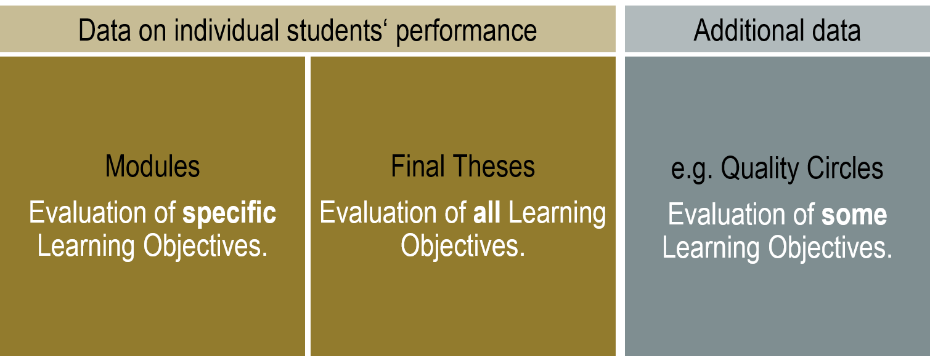

Assurance of Learning at the School of Management and Technology considers data on individual student’s performance and more general data on the program, e.g. from faculty-student discussions in Quality Circles and from graduate surveys.

# Improving study programs

Information from AoL is integrated into the school’s Quality Management process. In this process, the program manager and faculty discuss the findings and include the information into the program’s teacher-student discussion that takes places every year. Colleagues from the team of the Dean’s office facilitate this process together with Team Q. In this process, data is evaluated, measures and improvements are being developed and documented. Improvements usually concern the curriculum design, the evaluation process itself, or the teaching coordination (see fig. 3).

Figure 3: **Improvement process based on AoL**

**Direct measures**

Teaching faculty evaluates student performance in final theses and in selected modules. AoL Manager analyzes and merges evaluation data.

Program directors, coordinators, managers, faculty, and AoL Manager discuss the results of direct and indirect measures in the **annual strategic program meeting** prior to each program’s Quality Circle. Presentation of results and discussion of improvement measures in annual program **Quality Circle**, incl. program directors, faculty, and student representatives.

**Indirect measures**

Topics related to Competency goals are placed in graduate surveys, teaching evaluations, Quality Circles, and Internal Audit Procedures. AoL Manager analyses and merges the respective data.

**Collect and analyze data on**

**student learning**



**Develop curricular**

**improvements**



**Implement improvements**



**Improvements refer to process**

Time frame: about 0.5-1 year

**Improvements refer to curriculum structure and content**Time frame: about 1.5-2 years

**Improvements refer to curriculum content**

Time frame: about 0.5-1 year

Information from the measurements of student performance flows through different steps and can results in changes in a program’s FSA, in changes in teaching coordination and in changes of the AoL-process.

# Contact and Feedback

Your contact for any question regarding AoL is Dr. Lotte Lutz of the Dean’s Office Team.

We are happy to receive your feedback, either personally or via email at [aol@leuphana.de](mailto:aol@leuphana.de)!